INNOVATE – CREATE – CULTIVATE FUND 2021 / 2022
Creative Practitioners Professional Development Fund
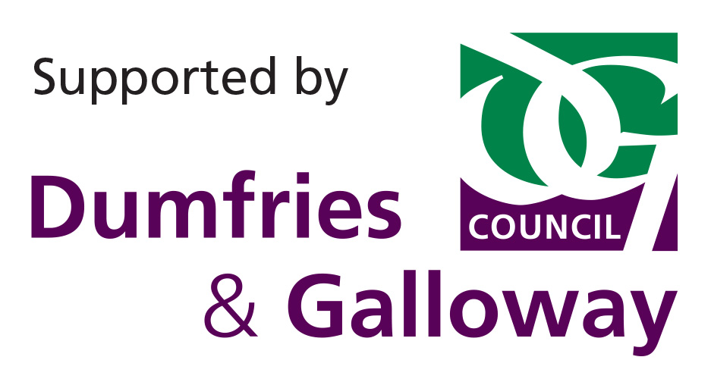

ELIGIBILITY TEST – DO YOU QUALIFY TO APPLY?

Double click on the box () that you want to select. A pop up menu will appear. In ‘Default Value’ select ‘Checked’. Click on the ‘OK’ button.

QUESTION | YES | NO
Can you confirm you are not in full or part-time education studying for a qualification related to your creative practice?
Can you confirm that your project is not part funded by (or that you don’t intend to apply to) another Dumfries and Galloway Council funding source?
Can you confirm that your project has not been completed?
Is your project start date (including further development of current work) at least 4 weeks after you plan to submit the application or the closing date for submissions, whichever is the earliest?
Can you confirm your application is NOT seeking funds to run a community and/or creative education project?
Are you based, or is your creative practice, based in Dumfries and Galloway?
Is your request for funding between £100 and £750?
Will your project be completed by 31st July 2022
Can you confirm you are NOT seeking a contribution towards new business start-up costs?
Can you confirm you are NOT seeking a contribution to overheads e.g. studio rent, utility bills, phone bills, office costs?
Can you confirm you are NOT seeking costs for website development or marketing costs?

Please note: If you answer ‘No’ to any of the above questions then you’re not eligible to apply at this time.

APPLICATION FORM

APPLICATION FORM  Innovate Create Cultivate Fund 2021/2022 | For our use only  Date received  Reference

Completed applications should be emailed to: comms.dgu@gmail.com.
You can submit an application at any time up until Midnight on Sunday 27th February 2022.

SECTION 1: ABOUT YOU
Double click on the box () that you want to select. A pop up menu will appear. In ‘Default Value’ select ‘Checked’. Click on the ‘OK’ button.

1.1 Please provide your contact details for this application.
Your title (please tick): | Dr Miss Mr Mrs Ms Other
Your name:
Your address and postcode:
Contact telephone and mobile number:
Your e-mail address:
Your website address:

We prefer to contact you by email. If you have provided an email address above, please tick to confirm that you check the mailbox regularly.

1.2 Please tell us for what you are seeking support for (Maximum 50 words). We may use this summary in our media releases and on our website.

1.3 Please tells us the start and end dates of your project.
Start date:
End date:

1.4 Please tick one main art form that describes your creative practice?

Multi-art form
Dance
Moving image
Literature
Music
Performing Arts
Other (please specify)

SECTION 2: YOUR PROJECT IN DETAIL

2.1 Please tick one main outcome your proposal meets

Outcome 1: Creative practitioner(s) increase their skills, technical ability, efficiency and confidence.
Outcome 2: Creative practitioner(s) help the region’s arts sector thrive, become stronger and more sustainable.

2.2 Describe how your proposal will deliver the main outcome. (Maximum 200 words):

SECTION 3: PROJECT BUDGET

3.1 Please complete the budget summary table below.
(You can apply for up to 100% of project costs).
a) What is the total cost of your project? | £
b) How much funding are you requesting from DG Unlimited? | £

3.2 Please detail the total costs of your project in relation to this grant application.
Expenditure Items | You must tick each item you are asking DGU to fund or contribute towards. | Cost (£)
TOTAL  (this should be the same as in Q3.1a) |  | £

3.3 Please tell us from where the money for this project will come.
(You can apply for up to 100% of project costs).
Source of other funding | Amount available or applied for (£) | Has this been confirmed? (Please put ‘Yes’ or ‘No’) | If ‘No’ when do you expect to receive confirmation
Request from Innovate Create Cultivate Fund
(This should be the same as in Q3. 1b)
Other funding avenues (please specify, e.g. own resources, another funder)

TOTAL
(This should be the same as in Q3. 1a)

SECTION 4: CREATIVE PRACTICE SUPPORTING MATERIAL

4.1 Please provide 3 examples of previous recent work or reviews from specialist, national or local media. (Examples of formats - Audio: SoundCloud; Video: YouTube or Vimeo links; jpg, pdf.)
Example | Title of Work | Year completed | Published / performed/ screened etc. (Where, when, by whom etc.) | Link to example of previous work (including password if applicable)
1
2
3

SECTION 5: DECLARATION
I confirm that the information in this application, including the supporting documents, is true and correct and I acknowledge that it is my responsibility to inform DG Unlimited immediately of any changes that could affect the interpretation or context of the application.
I confirm that I will complete an end of project monitoring and evaluation form.

Please note: an electronic signature is acceptable

Your signature: |  | Date:

Please Print Your name:

SECTION 6: CHECKLIST

6.1 Please tick the appropriate boxes below.
I have fully completed the application form, including the eligibility check, and signed the declaration in section 5.
I have enclosed an up to date artist’s CV.
I have enclosed a Mentor’s CV (if you are applying for the costs towards a Mentor, and have identified a particular individual, please also include either a web link or CV for your chosen Mentor).
I have enclosed a web-link to a conference or training course (if you are applying to attend a conference or course please also include either a web link or appropriate documentation to evidence the quality and relevance of the opportunity).

Completed applications should be emailed to: comms.dgu@gmail.com You can submit an application at any time up until Midnight on Sunday 27th February 2022.

